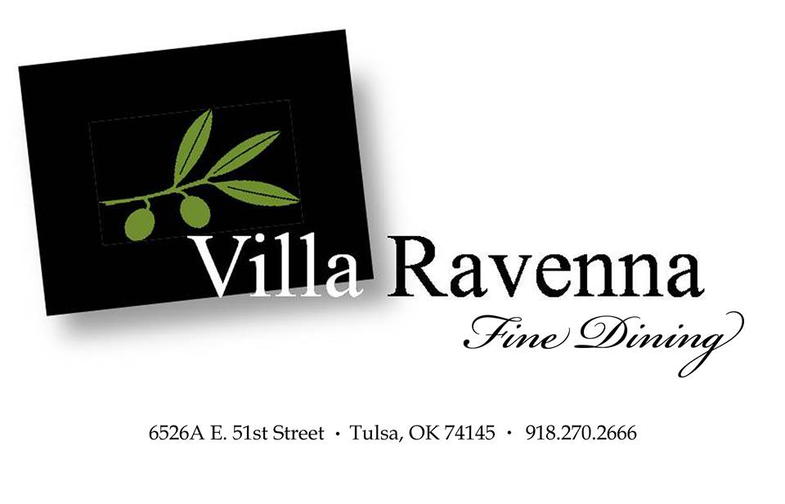

Wednesday 13^{th,} 2019

6:30 PM
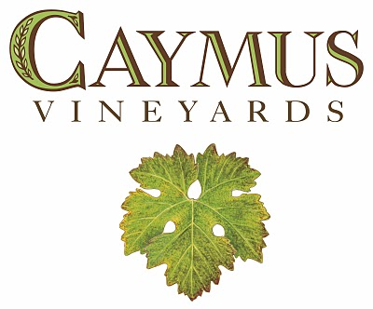
Caymus is located on 73 acres in Rutherford - owned and farmed since the 1940s by the Wagner family. The families of Caymus founders Charlie and Lorna Belle Glos Wagner emigrated from the winegrowing regions of Alsace, France and Rheinpfalz, Germany, respectively, and have roots in Napa Valley going as far back as the mid-1850s.
At the age of 19, Chuck Wagner joined his parents Charlie and Lorna in founding Caymus Vineyards with its first vintage of Cabernet Sauvignon produced in 1972. In 1975, the Wagners produced their first Special Selection Cabernet Sauvignon made from outstanding Cabernet lots of that vintage. It is the only wine to have twice been named Wine Spectator magazine's "Wine of the Year" for the 1984 and 1990 vintages. Both Charlie and Chuck Wagner were honored with Wine Spectator's "Distinguished Service Award" for their contributions to the American wine industry. Today the Wagner Family produces numerous award winning wines including Caymus, Conundrum, Mer Soleil, Red Schooner, and Emmolo.

Guests will be greeted with a Glass of Conundrum Sparkling Wine.
$ 149 per person plus tax and gratuity
Prepaid Reservations Required
https://www.giftrocker.com/secure/Order/?h=1f571375

Guest will be greated with a glass Conundrum 40th anniversary sparkling wine
1st Course
Bufala Mozarella
2015 Emmolo Sauvignon Blanc-Rutherford, Napa Valley, California
An elegant and refined style of Sauvignon Blanc that is subtle and balanced, with minerality and bright natural acidity. On the nose, aromas of citrus, iron, wet stone and a hint of D'Anjou pear tempt your senses, while a crisp lightness and underlying notes of fleshy grapefruit and lime zest please the palate.
2nd Course
Seafood Risotto
2014 Mer Soleil Chardonnay – Santa Barbara County, California
Greenish-golden in hue. Piercing aromas of ripe apple, pear, and pineapple, with a hint of coconut, very lightly touched with new-wood vanilla (while all the wine was barrel-fermented, Wagner used just 30% new French cooperage in 2014). Rich, weighty, broad, and dense on the attack, filled with apple and pear compote, hints of honey and anise, and finishing with just enough acid backbone to keep the tremendous tropical-fruit opulence of the vintage in check.
3rd Course
ROASTED CORNISH HEN, SERVED WITH WHIPPED POTATOES AND GREEN BEANS
2015 Emmolo Merlot – Napa Valley, California
A dark plum color, this wine opens with the lush scents of baking chocolate and fig, enhanced by notes of dried stone fruit, Christmas spice and wisps of Mesquite smoke. The palate is wonderfully rich and supple, driven by dark berry flavors. On the finish: a harmony of fresh earthiness and smoky notes rounded out with tannins that are leathery and smooth.
4th Course
ANGUS PRIME TENDERLOIN WITH BLACK TRUFFLE CEAME SAUCE
2015 Red Schooner Voyager 6
scents of ripe plums and cherries, this wine is powerful and supple, with flavors of French oak and soft tannins.

5th Course
BISON TENDERLOIN, SERVED WITH MADEIRA SAUCE AND ROASTED POTATOES
2015 Caymus Cabernet Sauvignon – Napa Valley, California
This wine has a signature style that is dark in color, with rich fruit and ripe, velvety tannins – as approachable in youth as in maturity. Caymus farms Cabernet grapes in eight of Napa’s 16 sub-appellations, with diversification enabling the winery to make the best possible wine in a given year. This Cabernet offers layered, lush aromas and flavors, including cocoa, cassis and ripe dark berries.
Dessert
CHOCOLATE MOUSSE WITH WHIPPED CREAM
Barolo Chinato
Barolo Chinato is a wine flavored with herbs, spices, and other aromatics, all added to Barolo wine. The most defining addition, however, is quinine bark, the same thing you find in tonic water! This gives the wine a gentle edge of bitterness. Combined with the rich, ripe notes of the wine, and its natural sweetness, as well as the other aromatics, this makes for a unique and delicious drinking experience.

